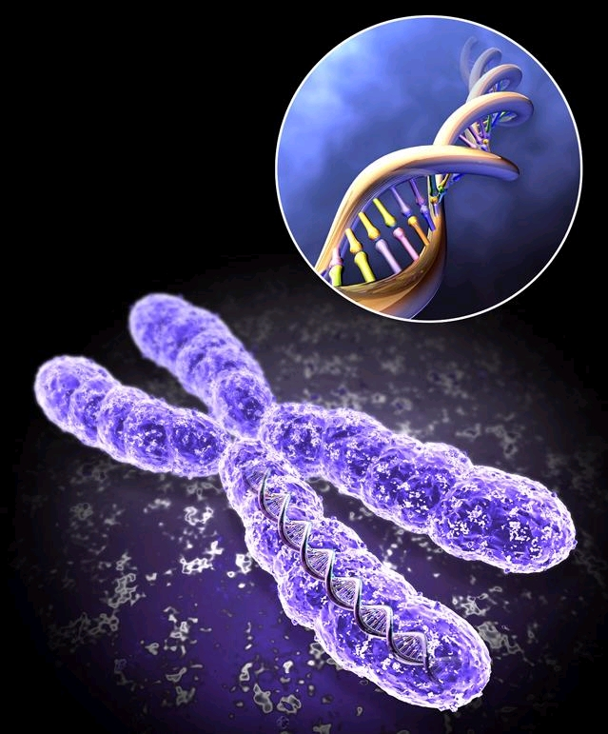
SSIP 2018 JANUARY

LIFE SCIENCES GRADE 12
TRAINER’S MANUAL

Copyright

This work is protected by the Copyright Act 98 of 1978. No part of this work may be reproduced or transmitted in any form or by any means, electronic or mechanical, including photocopying, recording or by any information storage and retrieval system, without permission in writing from Sci-Bono discovery Centre.
Whilst every effort has been made to ensure that the information published in this work is accurate, Sci-Bono Discovery Centre takes no responsibility for any loss or damage suffered by any person as a result of the reliance upon the information contained therein.

Icons
- Discussion | 
- Group Activity | 
- Individual Activity | 
- Study Tips | 
- Notes | 
- Ice Breaker | 

Training Programme

DAY ONE
Session I
Plenary : 16:00 – 17: 00
Session II
Registration and Administration : 17:00 – 18:00
Pre- Assessment : 18: 00 – 19: 00
Dinner : 19:00 – 20:00

DAY TWO
Session I
Skills in Life Sciences : 08:00 – 10:00
Tea Break : 10:00 – 10:15

Session II
Skills in Life Sciences : 10:15 – 13:00
Lunch Break : 13:00 – 14:00

Session III
Hypothesis testing : 14:00 – 15:00
Tea Break : 15:00 – 15:15
Session IV
Assessment in Life Sciences : 15: 15 – 18:00
Tea Break : 18:00 – 18:15

Session V
Assessment in Life Sciences : 18: 15 – 20: 00
Dinner : 20:00 – 21:00

DAY THREE
Session I
DNA- code of life : 08:30 – 10:00
Tea Break : 10:00 – 10:15

Session II
Protein synthesis : 10:15 – 12:00
Post Test : 12:00 – 13: 00
Closing Session : 13:00 – 13:20
Lunch : 13: 20 – 14: 30

Module 1
Skills in Life Sciences

A. GRAPHING SKILLS
LINE GRAPHS
Answer of the exercise
STEP 1:
Variables:
Independent: Position of the lamp
Dependent: Diameter of pupil

STEP 2 & 3
1 2 3 4 5 6 7
Diameter of the pupil (mm)
Distance of the lamp (m)
0.8
1.6
2.4
3.2
4.0
4.8

STEP 4, 5 & 6
A line graph indicating the diameter of the pupil of a person if a lamp is placed at different distances from the person.
1 2 3 4 5 6 7
Diameter of the pupil (mm)
Distance of the lamp (m)
0.8
1.6
2.4
3.2
4.0
4.8

PIE CHARTS
Answer of the activity
Calculations:
Transport = 25/100 x 360° = 90°
Residential = 27/100 x 360° = 97.2° ≈ 97º
Industrial = 15/100 x 360°= 54°
Commercial = 28/100 x 360° = 100.8° ≈ 101º
Other = 5/100 x 360° = 18°

Mark allocation for the pie chart
Correct type of graph | 1
Title of graph(CO₂ emission + Sector) | 1
Calculations: | 1: 1-4 calculations correct  2: All 5 calculations correct
Correct proportion for each labelled slice | 1: 1 to 2 slices correct  2: 3 slices correct  3: 4-5 slices correct
(7)

BAR GRAPHS
Answers for the questions
1.

2. a. Number of deaths in percentage.
b. Causes of death
HISTOGRAMS
Answers for the questions
Histogram showing the amount of decomposing bacteria found in soil with different pH levels
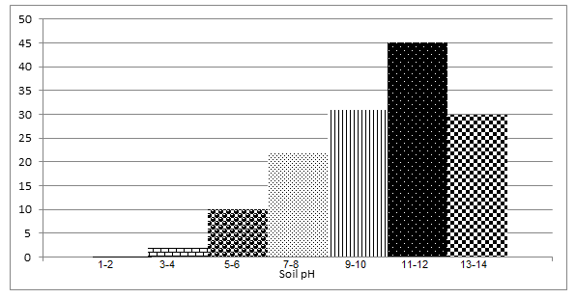
No. of decomposing bacteria
CALCULATIONS
Answers for the questions

- Percentage decrease: 32-45 x100
45
= 28.88%

- a)
P = F X S
M
P = Estimated total number of individuals in the population.
F = Number caught and marked in the first catch.
S = Number caught in the second catch.
M = Number marked in the second catch

F= 32
S = 26
M = 4
P = F X S
M
= 32 x 26
4
= 208
b)

Percentage marked sea snails in Pool B in second sample:
6 x 100
21
=28.57%
c) Average sea snails caught in both pools during first sample:
32+42
2
= 37
- 1cm = 10000 µm. 12cm = 120000 µm 1.2 cm = 12000 µm.
Actual size of cell =measured length of cell x number on scale
measured length of scale

= 12 0000 x 2
12000
= 20 µm.
DRAWINGS
Discussion:
- No heading
- Labels could all be on the right hand side of the drawing
- Diagram should not be shaded

Module 2
Scientific Method

MEMO
1.1(a) Amount of thyroxin√ (1)
(b) Body weight√ (1)
1.2- Same number of rats in each group√
- All rats were of the same species√
- All groups were investigated for the same period of time√
- All rats were the same gender√
- All groups were weighed after the same interval√ (Any 3)
(Mark first THREE only) (3)
1.3.Group A √ (1)
1.4- Low thyroxin levels√
- will lead to low metabolic rate√
- Therefore the energy from the diet is used very slowly√
- and more organic compounds are stored√ (Any 3) (3)
1.5Group B √ (1)
1.6.- These rats have high levels of thyroxin in their blood√
- therefore pituitary gland will not be stimulated√ to secrete TSH (2)
2.1.- Group A√
- Group C√
2.2. (a) Amount of Thyroxin√
(b) Metabolic rate√
By measuring the change in mass√/consumption of oxygen
2.3. Z, X, Y √√ (In the correct sequence)
2.4. Group B√
2.5. - The mass of the rats decreased/changed from 320 g to 309 g
- The oxygen consumption was the highest/(10ml/kg/min)
- indicating an increased rate of metabolism
- which is caused by the higher thyroxin concentration
- Diet Y contains the most thyroxin (5)
2.6- The age of the rats must be the same
- All the rats must receive the same amount of food
- The rats must be of the same species/genetically similar
- Use the same instrument to measure mass
- The same person must take the measurements (Any 3)
(MARK FIRST THREE ONLY) (3)

3.
3.1.Habitat√/colour of sand
- Fur colour√
(Mark first TWO only) (2)
3.2.100√ (1)
3.3.- They used a large sample size√/200 models per habitat/ 200
models per fur colour/ 400 models in total (2)
- Allowed enough time for predators to attack the models√
- Placed mice randomly in each habitat√ Any 2
(Mark first TWO only) (2)
3.4.The darker coloured models were attacked less√√ than the lighter
coloured models
OR
The lighter coloured models were attacked more√√ than the darker
coloured models
3.5.- More mice/78 models with dark fur colour were attacked√ in the
beach habitat
- as they were more visible√/less camouflaged against the light
coloured sand
- Fewer mice with light fur colour/26 models were attacked√ in the
beach habitat
- as they are less visible√ /well camouflaged against the light
coloured sand (4)

3.6- The clay models are not able to escape from predators√
- and therefore they would be attacked more frequently√
OR
- The owls will not recognise the models as prey√ and
- therefore will attack less frequently√
OR
-If the models showed signs of an attack√
-it doesn’t give an indication of their survival√ (2)
(13)

Module 3
DNA – the code of life

Memo:
DNA EXTRACTION ANSWERS

- DNA stands for deoxyribonucleic acid. DNA is a molecule in the form of a double helix - two spirals twisting around each other. These spirals are the backbone of the DNA, and are made up of sugars and phosphates. The spirals are connected by chemicals known as bases, which stretch between the spirals like the rungs of a ladder. DNA has four types of bases: adenine (A), thymine (T), guanine (G) and cytosine (C). A and T always join together, as do G and C.
- DNA is the genetic instruction manual for making an organism. All processes in the
body are controlled by DNA. A gene is a sequence of DNA.
- The dishwashing liquid bursts open the cells of the strawberries, releasing the DNA.
- It ensures that the proteins in the cell are not separated from the rest of the solution with the DNA.
- When molecules are insoluble (unable to be dissolved), they clump together and become visible. DNA is not soluble in alcohol; therefore, it makes the DNA strands clump together and become visible to the naked eye.

2.1.
2.1 | 8
2.2 | Translation
2.3 | tRNA / transfer RNA
2.4 | 5
2.5 | UAG
2.6 | - Each tRNA carries a specific amino acid  - When the anticodon of the tRNA  - Matches the codon on the mRNA  - Then tRNA brings the required amino acid to the ribosome  - Amino acids become attached by peptide bonds  - To form the required polypeptide / protein

3.1. Translation√
3.2 (a) Ribosome√
(b) mRNA√/messenger RNA
(c) Peptide√
3.3. (a) C√
(b) B√
(c) D√

Module 4
MEIOSIS

1.1.Telophase II (1)
1.2- There are four/4 cells
- Each cell contains only a single set of un-replicated/single
stranded chromosomes (MARK FIRST TWO ONLY) (2)
1.3. (a) Two /2
(b) Four/4 (2)
1.4.(a) - Crossing over
- Random arrangement of chromosomes on the equator
MARK FIRST TWO ONLY) (2)
(b) - The gametes that form will be genetically different
- leading to variation in the offspring
- This increases a species chances of survival (3)
(10
PRACTIAL WORKSHEET MEMORANDUM :
  - Anaphase
  - Chromatids moving to opposite poles to form a 4 cell stage
  - Prophase
  - Homologous chromosomes arranged in pairs
  - Metaphase
  - Chromosomes arranged at equator in 2 celled stage
  - Telophase
  - Daughter cells, with daughter chromosomes are forming in nuclei
2. B, C, A, D
3 Anaphase I of meiosis
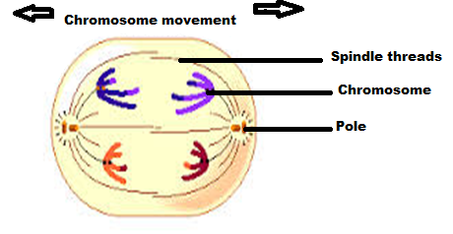

4.1 Anther and ovary
4.2 Testes and ovary
5. Two daughter cells.
6. Gametes/sex cells
7. For genetic variation
Keeps number of chromosomes constant

Module 4
Assessment in Life Sciences

